

INSTALLATION MANUAL

Table of Contents

Applicable Version………………..….……………………………….……………………….………3

Prerequisite..……………………………………………………….……………………………………….4

Installation....………………………….……….………………………………………………………….5

Configuring worldline……………………………………………………………………………………7

Applicable versions

- PHP

- PHP 5.5.22 to 7.2.x

- Prestashop

- Prestashop 1.6.x to 1.7.x

Prerequisite

Make sure that following DLLs are enabled in PHP configuration file to work with worldline Payment Gateway:

extension = php_soap.dll
extension = php_openssl.dll
extension = php_curl.dll
extension= php_mcrypt.dll

Installation

Please follow the given steps to install and run the worldline Payment Gateway module

1. First, you need to log in to the Prestashop administrator area.
a. Visit URL www.<mysite.com>/admin.
b. Enter Username and password.
2. Then go to Modules > Module Catalog. Then click on Upload a module button. A pop-up window will open. Then click on select file and select the package file.
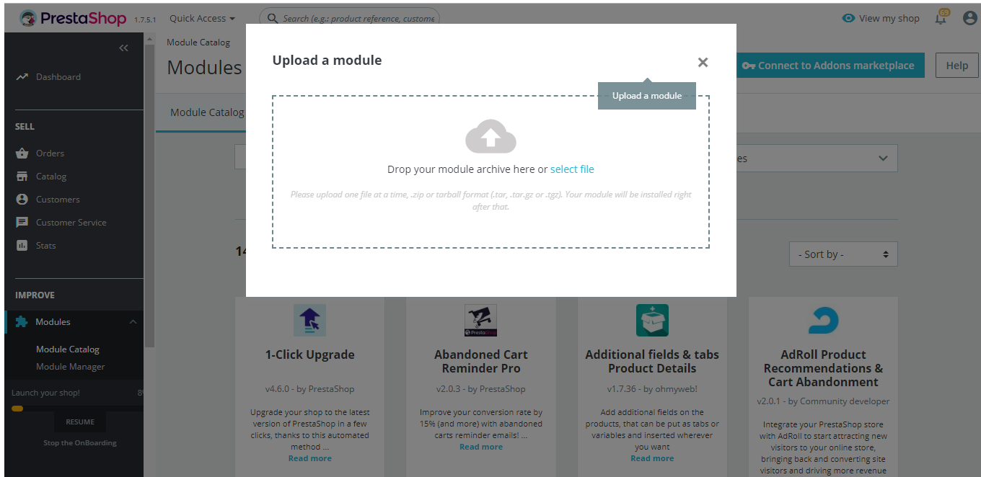
3. When you select package file wait for success message module to get installed.

Configuring worldline

- Go-to admin panel.
- Go-to menu Module ->Module Manager.
- Search for 'worldline' module.
- Click on Configure.
- Configure it as below:
Column Name | Description
Enabled | “Yes” to enable and use, else “No” to disable worldline
Title | Title Text to display during checkout process
IV | Enter IV.
Key | Enter Key.
Merchant Code | Enter merchant code.
Request Type | Select “T” for transaction request type.
New order status | Select as “Processing”
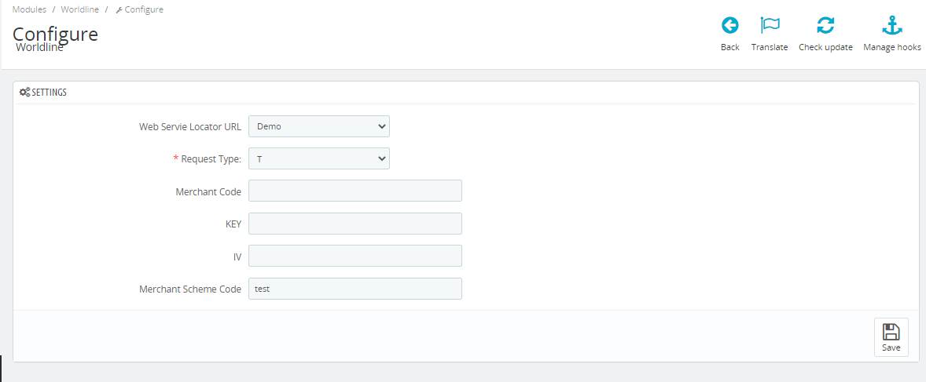

- Now click on “Save” button on bottom- right corner.
- worldline Payment Gateway is now configured & ready to use.

